**Tutorial 12: Multiple Components**

When making a whole website web page template inside one single components, then the component can end up getting very long, difficult to read and it becomes one big mess. The ideal practice is to split our code into separate Vue components.

For example we might want a component for the navbar, the header, the footer, etc. This makes each component more readable, easier to maintain, more modular and reusable. We can reuse components in multiple places in our websites.

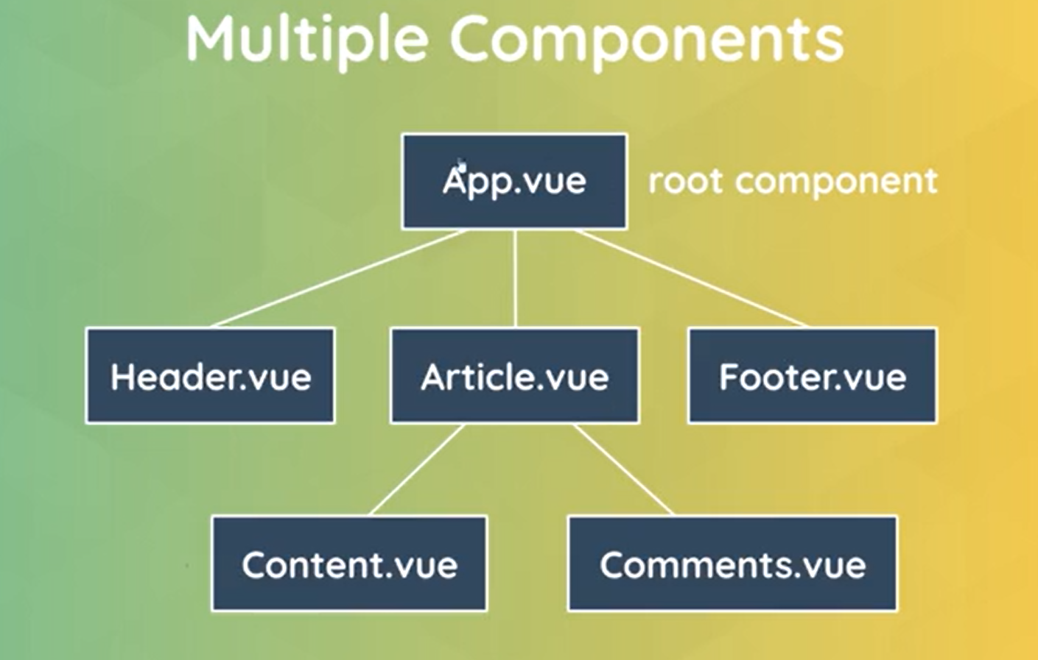

Every Vue app will always have a root component, **App.vue**. When we nest our components in other components we call them child components and the components they are nested in is the parent component.

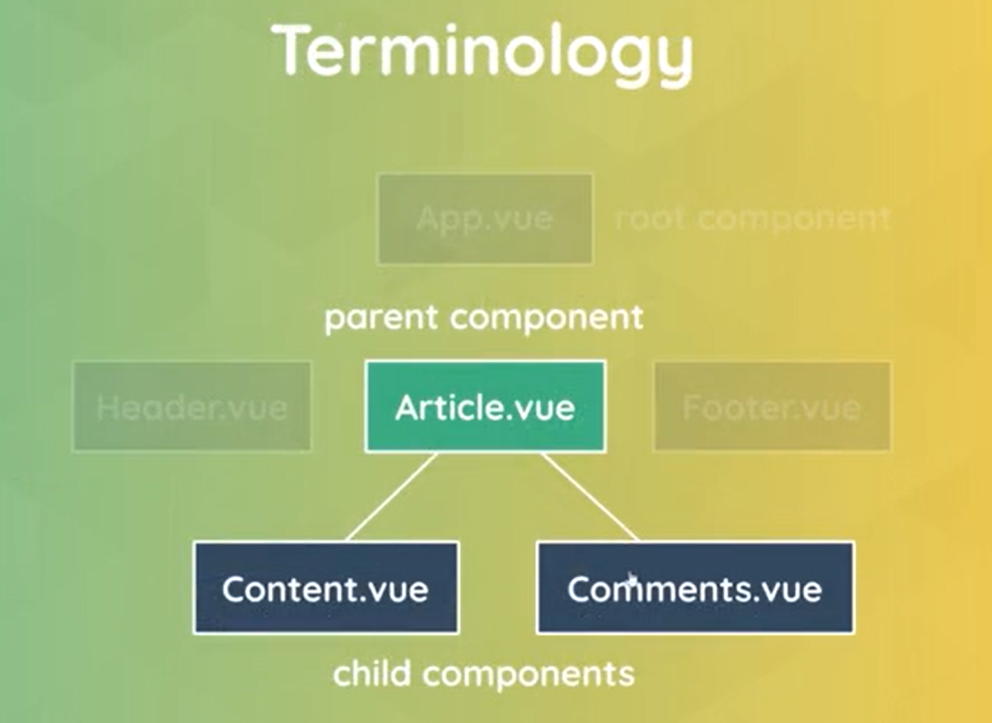

The whole structure of components in your website is called a component tree.

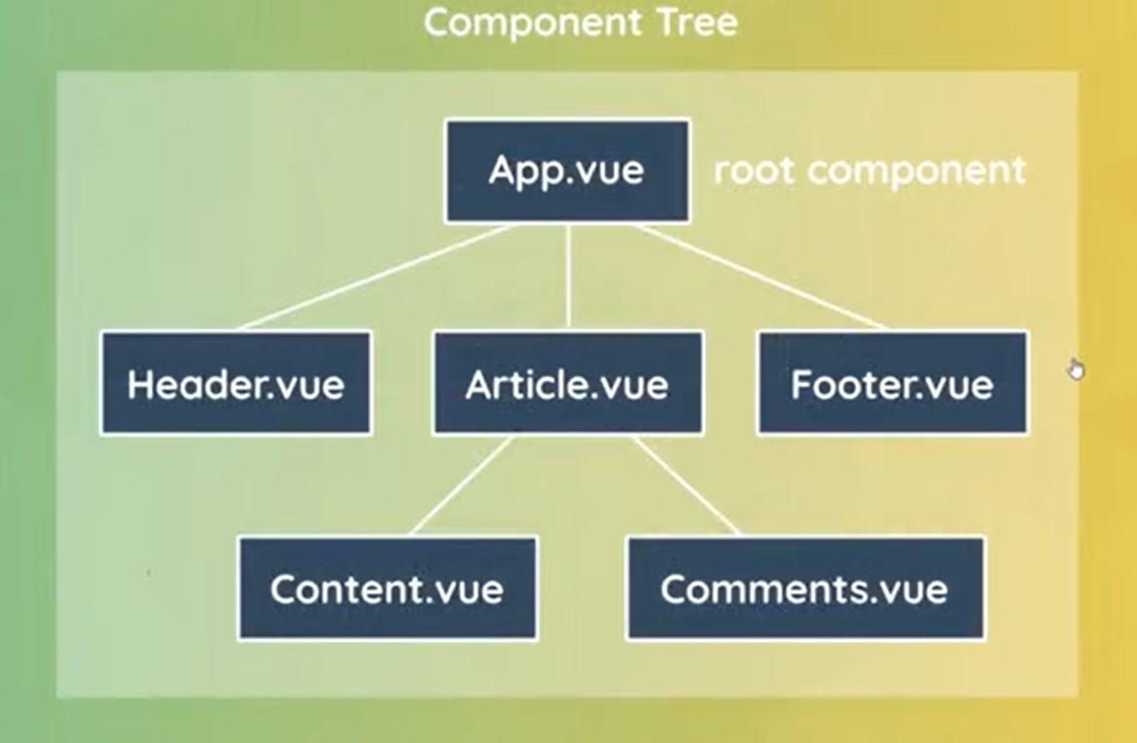

Make sure **Tutorial 11** is complete to be able to move on to this tutorial or clone the [vue3-firebase-course](https://github.com/younggrasshopperza/vue3-firebase-course) repository and go to branch called **Tutorial-11**.

**Step 1:** In the folder structure under the components folder, create a **Vue** file called **Modal.vue**.

Look at the example below:

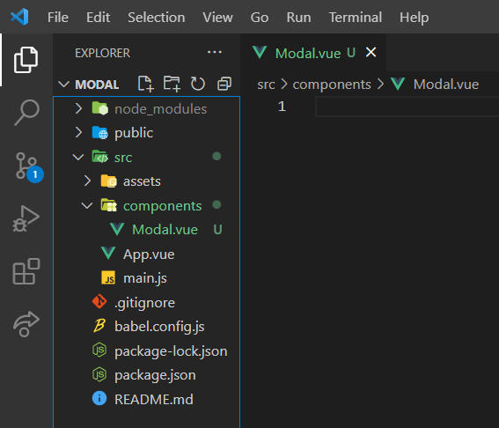

**Step 1:** In the modal.vue file, create a template. Inside the template create a div tag with a class called backdrop and inside the div tag create another div tag with a class called modal. Inside the div with the class modal create a paragraph tag with placeholder text.

Look at the example below (**Between** **Line 1 to 7**):

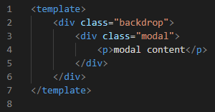

Create a style tag. Between the style tags paste the following CSS code below:

.modal {

    width: 400px;

    padding: 20px;

    margin: 100px auto;

    background: white;

    border-radius: 10px;

}

.backdrop {

    top: 0;

    position: fixed;

    background: rgba(0, 0, 0, 0.5);

    width: 100%;

    height: 100%;

}

**Step 2:** In the App.vue file, import the modal.vue file inside the script tag and give it a name of Modal. Register the Modal component by inserting the component inside an object called components. Then call the component in the template.

Look at the example below (**Line 3, Line 7, and Line 11**):

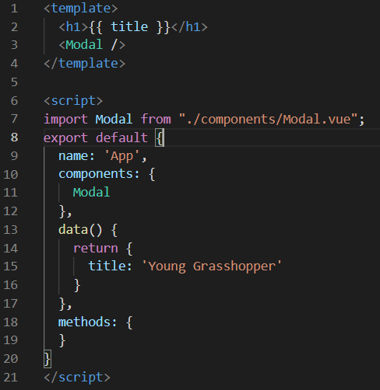

**Output:**

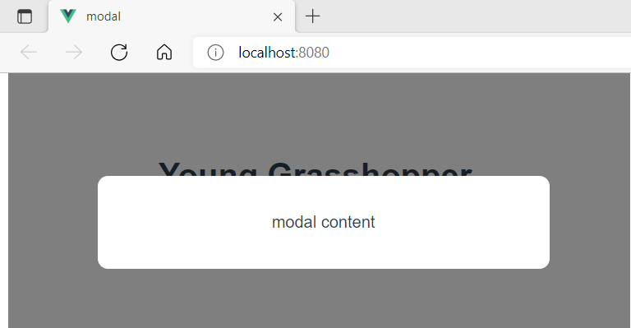

**You can view the code snippets from the** [**vue3-firebase-course**](https://github.com/younggrasshopperza/vue3-firebase-course) **repository under the Tutorial-12 branch.**